RANDOM FOREST REGRESSION

Random forest is a ***Supervised Machine Learning Algorithm*** that is ***used widely in Classification and Regression problems***. It builds decision trees on different samples and takes their majority vote for classification and average in case of regression.

One of the most important features of the Random Forest Algorithm is that it can handle the data set containing ***continuous variables*** as in the case of regression and ***categorical variables*** as in the case of classification. It performs better results for classification problems.

***Ensemble:*** simplymeans combining multiple models.

1. Basic Ensemble Techniques  
   2.1 Max Voting  
   2.2 Averaging  
   2.3 Weighted Average
2. Advanced Ensemble Techniques  
   3.1 Stacking  
   3.2 Blending  
   3.3 Bagging  
   3.4 Boosting

*Ensemble uses two types of methods*:

1. **Bagging**– It creates a different training subset from sample training data with replacement & the final output is based on majority voting. For example,  Random Forest.

2. **Boosting**– It combines weak learners into strong learners by creating sequential models such that the final model has the highest accuracy. For example,  ADA BOOST, XG BOOST

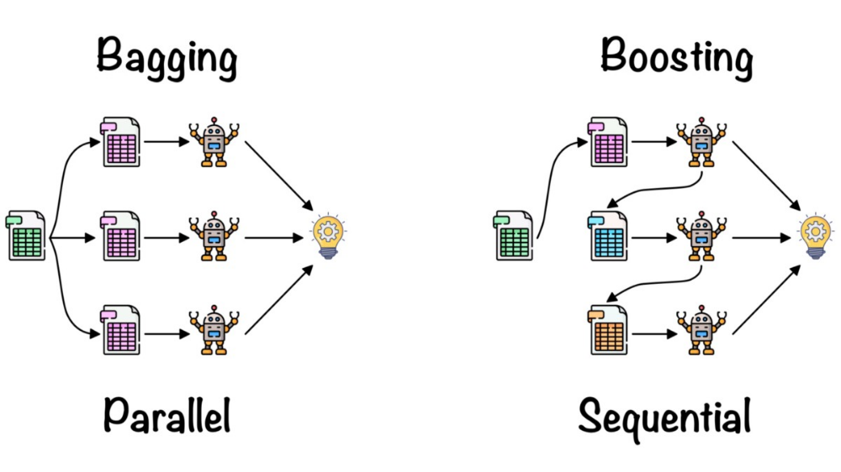

#### Bagging

Bagging, also known as ***Bootstrap Aggregation*** is the ensemble technique used by random forest.Bagging chooses a random sample from the data set. Hence each model is generated from the samples (Bootstrap Samples) provided by the Original Data with replacement known as ***row sampling***. This step of row sampling with replacement is called***bootstrap***. Now each model is trained independently which generates results. The final output is based on majority voting after combining the results of all models. This step which involves combining all the results and generating output based on majority voting is known as ***aggregation***.

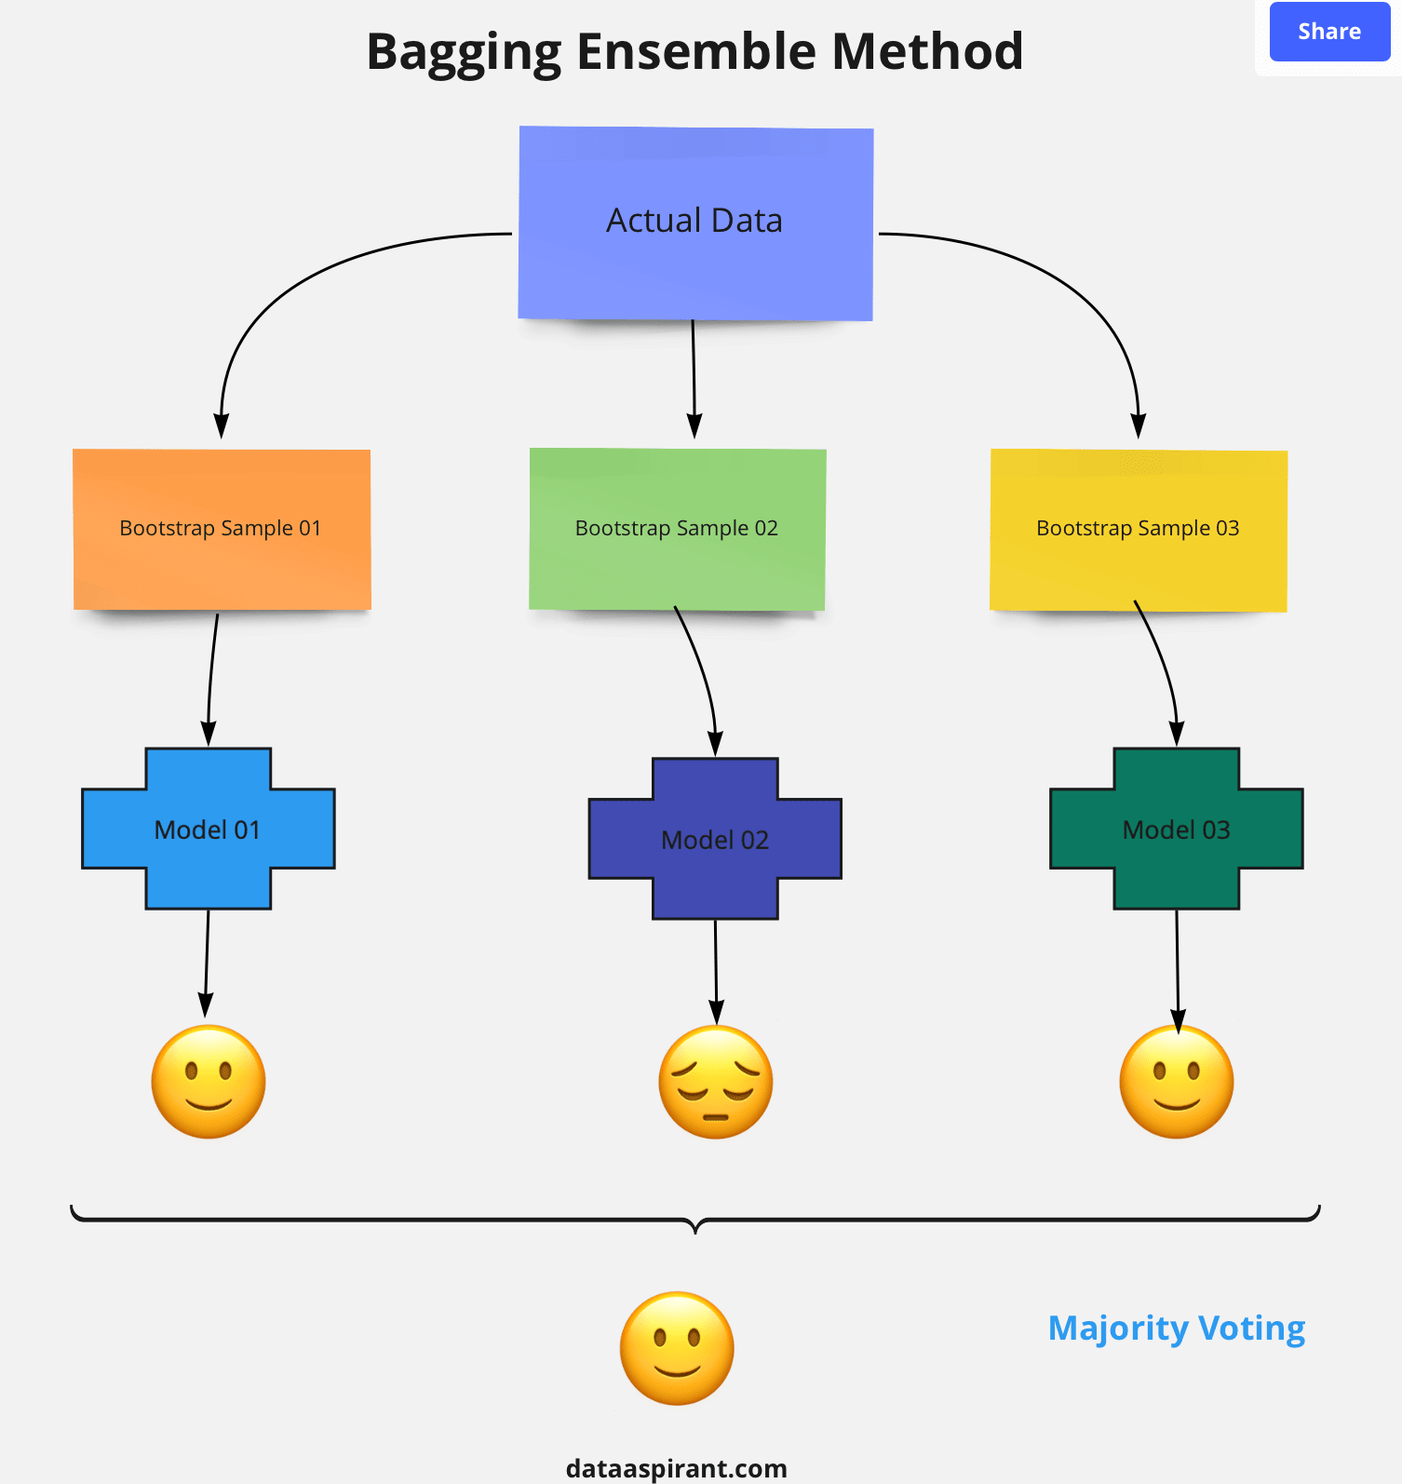

**Steps involved in random forest algorithm:**

Step 1: In Random forest n number of random records are taken from the data set having k number of records.

Step 2: Individual decision trees are constructed for each sample.

Step 3: Each decision tree will generate an output.

Step 4: Final output is considered based on ***Majority Voting or Averaging***for Classification and regression respectively.

### Difference Between Decision Tree & Random Forest

Random forest is a collection of decision trees; still, there are a lot of differences in their behavior.

|  |  |
| --- | --- |
| **Decision trees** | **Random Forest** |
| 1. Decision trees normally suffer from the problem of overfitting if it’s allowed to grow without any control. | 1. Random forests are created from subsets of data and the final output is based on average or majority ranking and hence the problem of overfitting is taken care of. |
| 2. A single decision tree is faster in computation. | 2. It is comparatively slower. |
| 3. When a data set with features is taken as input by a decision tree it will formulate some set of rules to do prediction. | 3. Random forest randomly selects observations, builds a decision tree and the average result is taken. It doesn’t use any set of formulas. |

Thus random forests are much more successful than decision trees only if the trees are diverse and acceptable.

